File No.: _____________  (For Secretarial use only) | ABSTRACT FORM  The 1st International Conference of the Jordanian Faculties of Pharmacy “JFP”  28-29/October/2015
File No.: _____________  (For Secretarial use only) | Deadline for receiving the abstracts: July. 15/2015  This official form must be used for submission of abstract
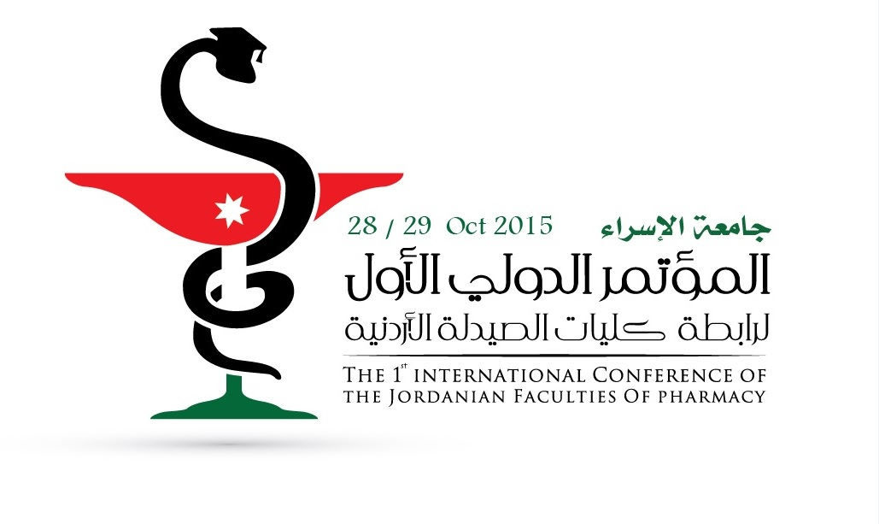
Please type the abstract within this space
Important
Please email abstract to:
Secretary General of the Conference
Dr. Zina Al-Alami
Faculty of Pharmacy
Isra University
Amman – Jordan
isra.ph.conf.2015@iu.edu.jo

Topics:
- Pharmaceutical Sciences.
- Pharmacoeconomics & Business.
- Pharmaceutical Biotechnology.
- Clinical Pharmacy & Pharmacy Practice

Subjects:
Please check using [X]
- Biochemistry
- Biotechnology
- Cancer Targeted Drug Delivery
- Clinical Pharmacy
- CNS Drug Delivery
- Gene Therapy
- Nanotechnology
- New Formulation Technology
- Novel Drug Delivery System
- Medicinal Chemistry
- Pharmaceutical Analytical Chemistry
- Natural Products
- Pharmaceutical Business
- Pharmacoeconomics
- Pharmacogenomics
- Pharmaceutical Technology
- Pharmacology
- Proteomics
- Others (please specify)
First name__________ Middle Name ___________ Family Name_________
Affiliation _____________________________________________________
Address_______________________________________________________
Postal Code__________ City_________________ Country______________
Phone No._____________________________ Fax. ____________________
Email_______________________________________________________

Abstract submission

Authors are invited to submit their abstracts reporting original work as well as proposals for special sessions in the mentioned areas. For publication issues, the articles should meet the standard format of the (Jordan Journal of Pharmaceutical Sciences). Which website is: (https://journals.ju.edu.jo/JJPS)

The title should be brief phrase (but informative enough to facilitate information retrieval); capitalize first letter of each word in the title, describing the contents of the paper. Authors’ full names and affiliations, the name of the corresponding author along with phone, fax and email information should be included
The abstract should be informative and completely self-explanatory, briefly present the topic, state the scope of the experiments, indicate significant data, and point out major finding and conclusion and should not exceed 150-250 words. Complete sentences, active verbs, and the abstract should be written in the past tense. Standard nomenclature should be used and abbreviations should be avoided. Non-standard abbreviations should be used only when the full term is very long and used often. No literature should be cited. Typing should be using font size 12, times new roman and 1.5 space in one paragraph.
Key words (up to five words) must be provided below the abstract to assist with indexing of the article.

Registration Fees:

Registration fees cover the scientific conference & lunches. It does not cover any accommodation.
Payment of registration fees is made via cash or cheque payable to Isra University, account number: 162-40215-0-501 – Arab Bank – Amman – Jordan.

- Fees for Participants with presented abstracts: No charges for the abstract presenters.

- Fees for Jordanian Participants

- Faculties’ members: No charges before 30/June/2015 and 50 JD after this date (until 15/September/2015).

2. Health and industrial sectors: 50 JD before 30/June/2015 and 100 JD after this date (until 15/September/2015).

- Fees for international Participants: 100 $ before 30/June/2015 and 200 $ after this date (until 15/September/2015)

Contact us:

Faculty of Pharmacy - Isra University
Secretary General of the Conference Dr. Zina Al-Alami
By Email, paper mail, telephone calls or Fax.
- Conference Email: isra.ph.conf.2015@iu.edu.jo
- Postal Address: Isra University P.O. Box 33 Amman 11622 Jordan
- Telephone numbers: 0096264711710 extensions 2730 or 2737
Sunday through Thursday from 8 AM till 4 PM
- Fax: 0096264711505
- Website: http://www.iu.edu.jo/conference/confPhar/index.php

